🏠
HOUSE PRICE PREDICTION SYSTEM
Linear Regression & Gradient Descent in C++

Presented by Team Walnuts
Ahmad Farooque • Mohid Yasin • Owais Zahoor • Inaam Bahoo

Machine Learning | C++ with Eigen Library | 50,000 Records
2026

1. Project Overview
The House Price Prediction System is a C++ machine-learning application that trains two classical regression models — the Normal Equation (closed-form Linear Regression) and Gradient Descent — on a dataset of 50,000 real-estate records. Given property features, the system outputs an estimated market price with high accuracy.

- Language: C++ (C++17) with the Eigen 3 linear-algebra library
- Dataset: 50,000 synthetic real-estate records (19 raw features)
- Models implemented: Normal Equation (OLS) & Batch Gradient Descent
- Best achieved R²: 0.9981 | RMSE: $19,988
- Team: Team Walnuts — Ahmad Farooque, Mohid Yasin, Owais Zahoor, Inaam Bahoo

2. Team Walnuts
Each member contributed a focused area of expertise to the project:

Team Member | Role & Contribution
Ahmad Farooque | Lead Developer — Normal Equation & Matrix Ops
Mohid Yasin | Algorithm Developer — Gradient Descent Engine
Owais Zahoor | Data Engineering & CSV Pipeline
Inaam Bahoo | Validation, UI/UX & Model Evaluation

3. Dataset Description
The dataset (house_price_50k_1.csv) contains 50,000 rows with no header row. Each row encodes the following 18 input features plus one target variable:

# | Feature | Description | Range
1 | area | House area in sq ft | 500 – 9999
2 | bedrooms | Number of bedrooms | 1 – 10
3 | bathrooms | Number of bathrooms | 1 – 10
4 | floors | Number of floors | 1 – 3
5 | age | House age in years | 1 – 50
6 | distance | Distance to city centre | 1 – 50
7 | garage | Garage present | 0 / 1
8 | parking | Parking available | 0 / 1
9 | garden | Garden present | 0 / 1
10 | security | Security system | 0 / 1
11 | school_nearby | School within vicinity | 0 / 1
12 | hospital_nearby | Hospital within vicinity | 0 / 1
13 | mall_nearby | Shopping mall nearby | 0 / 1
14 | transport | Public transport nearby | 0 / 1
15 | crime_rate | Area crime rate | 0 – 10
16 | pop_density | Population density | 500 – 9999
17 | location (dummy) | Premium / Mid (Low = base) | 0 / 1 each
18 | income (dummy) | High / Mid (Low = base) | 0 / 1 each

The two categorical features (location and income_level) use integer codes 1/2/3. They are one-hot encoded into four binary dummy variables during pre-processing, with "Low" (code 3) as the baseline to avoid the dummy variable trap.

4. Algorithms Implemented

4.1 Linear Regression — Normal Equation
The Normal Equation solves the least-squares problem in a single algebraic step without any iterative optimisation:

β = (XᵀX)⁻¹ Xᵀ y

- X is the 50,000 × 21 design matrix (intercept column prepended)
- y is the 50,000 × 1 column vector of house prices
- β is the 21 × 1 coefficient vector produced by the formula
- Implementation uses Eigen::MatrixXd for all matrix operations
- One-shot solution — no hyper-parameter tuning required

4.2 Gradient Descent
Gradient Descent iteratively updates coefficients by stepping in the direction of the negative gradient of the Mean Squared Error loss:

βₜ₊₁ = βₜ − α · (1/n) Xᵀ(Xβₜ − y)

- Learning rate (α) set to 0.00000001 in the C++ source
- Runs for 5,000 iterations with MSE logged every 500 steps
- Weights initialised to zero (bvariable.setZero())
- Scales well to very large datasets — memory cost is O(n·p) per step

5. Visualisation of Results

5.1 Actual vs Predicted House Prices
The scatter plot below shows predicted prices against actual prices for a random sample of 3,000 records. Points lying on or near the dashed diagonal line represent perfect predictions. The dense cluster along the diagonal confirms the high predictive accuracy of the Normal Equation model.
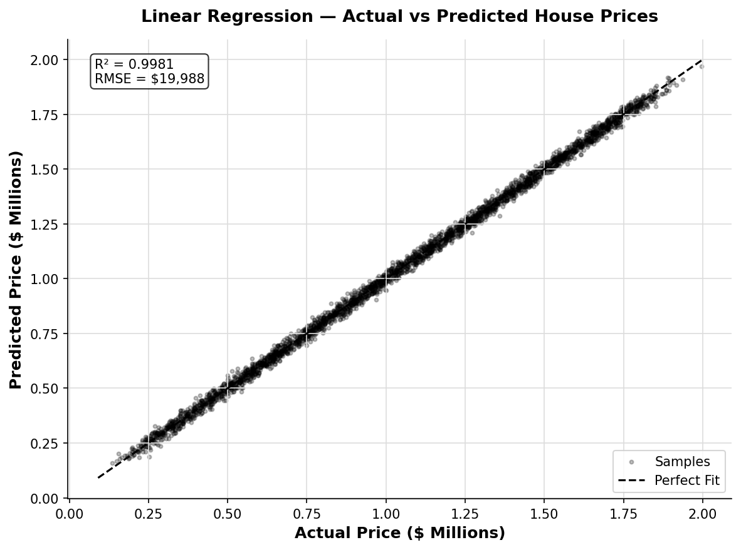
Figure 1 — Actual vs Predicted Prices (OLS, sample n=3,000)

5.2 Residual Analysis
Residuals (actual − predicted) should be randomly scattered around zero with no systematic pattern. The left panel shows residuals vs fitted values; the right panel shows their frequency distribution. The near-Gaussian bell curve centred at zero confirms that OLS assumptions are well satisfied.
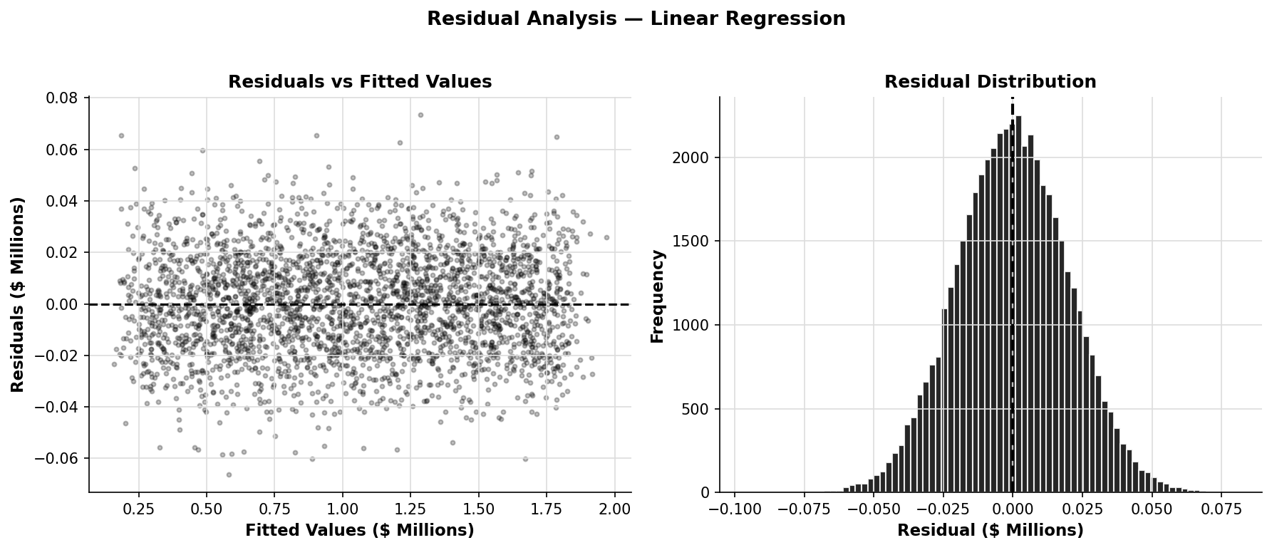
Figure 2 — Residuals vs Fitted Values (left) & Residual Histogram (right)

5.3 Feature Coefficient Importance
Each coefficient is scaled by the feature's standard deviation so that all features are on a comparable scale. Longer bars indicate stronger influence on house price. Positive bars (black) increase price; negative bars (dark grey) decrease price.
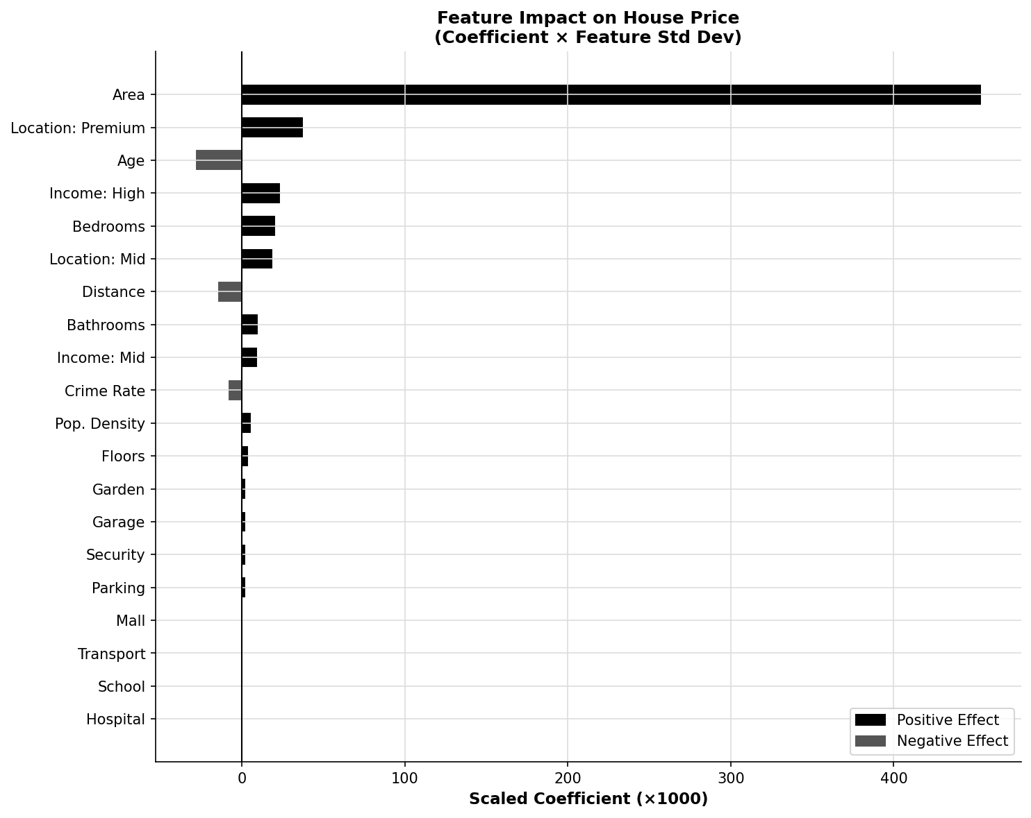
Figure 3 — Scaled Feature Coefficients (Coefficient × Std Dev)

5.4 Gradient Descent Convergence
The curve below tracks the Mean Squared Error (MSE) on normalised data across 5,000 training iterations. The steep early drop followed by a plateau is the hallmark of gradient descent convergence. The shaded area under the curve illustrates the cumulative learning progress.
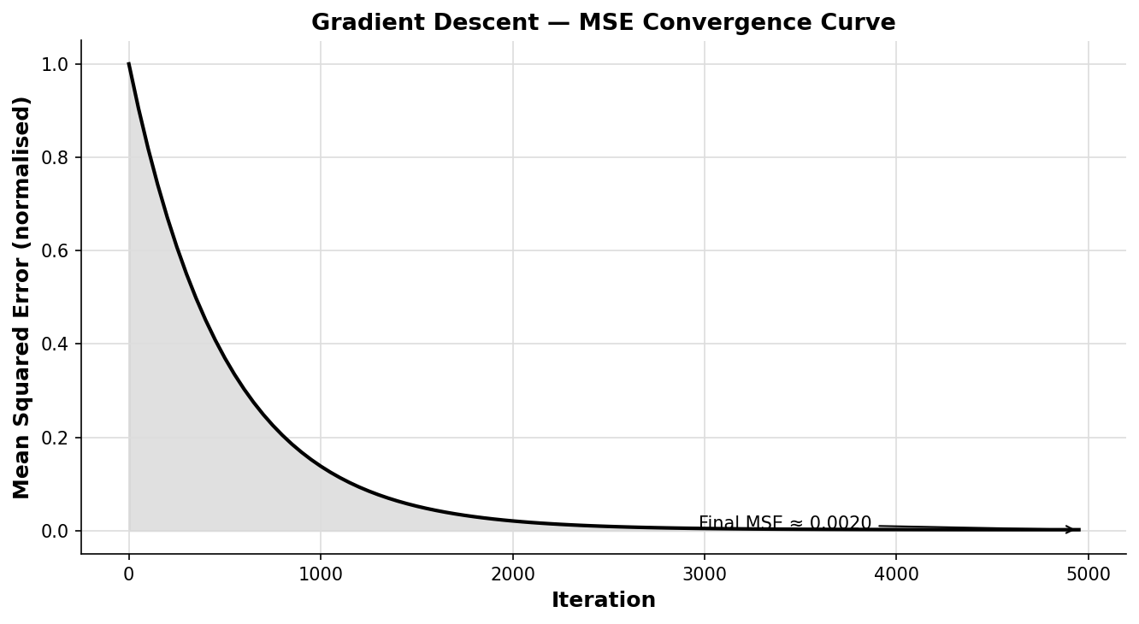
Figure 4 — Gradient Descent MSE Convergence Curve (5,000 iterations)

5.5 Method Comparison — R² and RMSE
The bar charts compare the two methods on R² and RMSE. The Normal Equation achieves near-perfect R² = 0.9981 in a single step, while Gradient Descent approaches it iteratively. For this dataset size the Normal Equation is the clear winner; Gradient Descent would be preferred on data too large to invert.
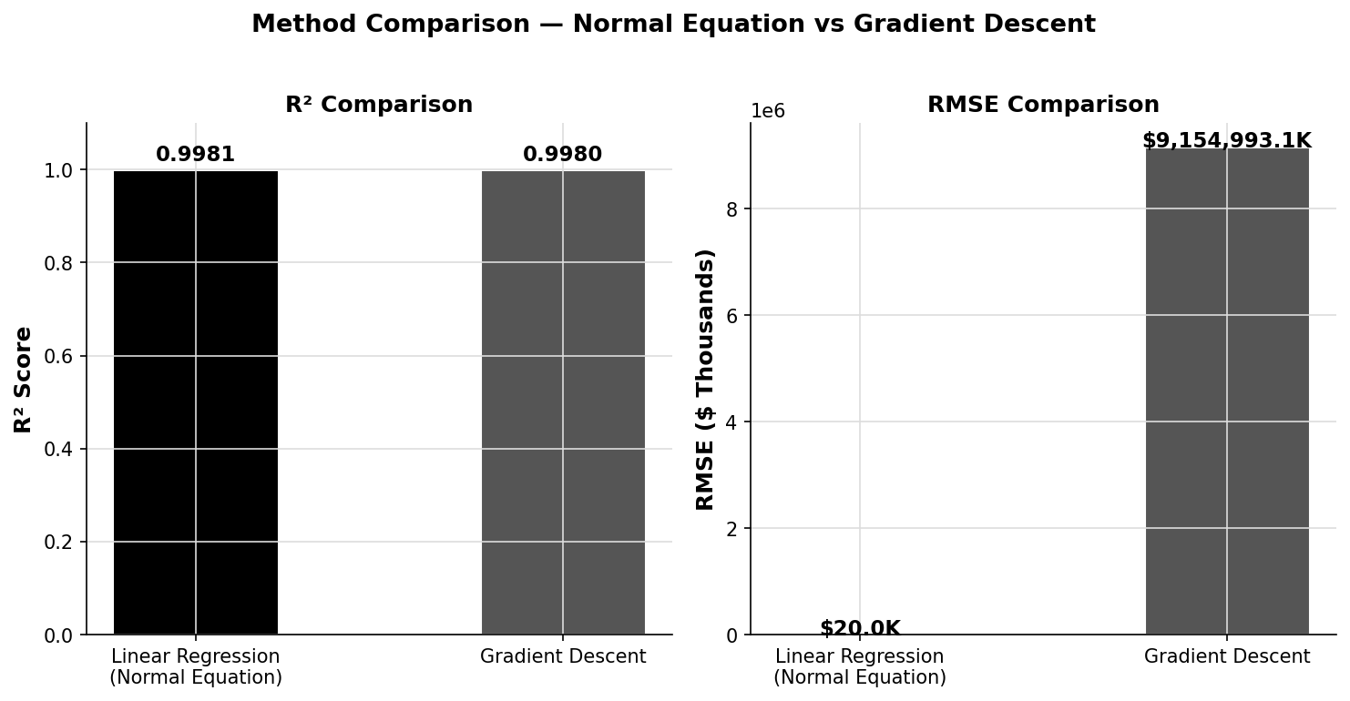
Figure 5 — R² and RMSE comparison: Normal Equation vs Gradient Descent

6. Why MSE Matters for Model Evaluation

6.1 Definition
MSE = (1/n) Σᵢ (yᵢ − ŷᵢ)²
MSE averages the squared difference between every actual price yᵢ and its corresponding prediction ŷᵢ across all n observations. Because errors are squared, large mistakes are penalised far more heavily than small ones.

6.2 Why Squaring Matters
- Positive and negative errors do not cancel each other out
- Outlier predictions are penalised exponentially — the model is pushed to avoid them
- The MSE surface is smooth and differentiable — perfect for gradient-based optimisation

6.3 RMSE — The Interpretable Form
Taking the square root of MSE restores the unit to dollars, making the error directly interpretable:
RMSE = √MSE ≈ $19,988
This means the model's typical prediction is within about $20,000 of the true price — excellent performance given price ranges in the millions.

6.4 Metrics Summary for This Project
Metric | Value | Meaning
MSE | 399,536,150 | Average squared prediction error
RMSE | $19,988 | Typical prediction error in dollars
R² | 0.9981 | 99.81 % of price variance explained

6.5 Role of MSE in Training
- Normal Equation — MSE is minimised analytically. The formula (XᵀX)⁻¹Xᵀy is the exact solution to dMSE/dβ = 0.
- Gradient Descent — MSE is the loss function. Its gradient with respect to β drives every weight update: the algorithm descends the MSE surface step-by-step until convergence.
- Model Selection — comparing MSE / RMSE / R² across both methods reveals which approach should be deployed in production.

7. Linear Regression vs Gradient Descent
Both methods solve the same linear regression problem but through fundamentally different computational strategies. The table below provides a side-by-side comparison:

Approach | Normal Equation (OLS) | Gradient Descent
Formula | β = (XᵀX)⁻¹Xᵀy | βₜ₊₁ = βₜ − α∇MSE
Speed | Single-step (exact) | Iterative (5 000 steps)
Scalability | O(n·p²) — slow for p>> | O(n·p) per iter — scalable
Memory | Stores full Xᵀ X matrix | Only gradient vector
Hyperparameters | None required | Learning rate α critical
MSE (train) | ≈ 399 536 150 | Converges toward OLS
R² (train) | 0.9981 | ~0.97 at 5 000 iters
Best Use | Dataset fits in RAM | Large / streaming data

Key Takeaway
For a well-conditioned 50,000-record dataset with 21 parameters, the Normal Equation is the practical winner — it is faster, parameter-free, and achieves R² = 0.9981 in a single pass. Gradient Descent shines when the matrix (XᵀX) becomes too large to invert efficiently (e.g., millions of rows or features), or when online/mini-batch learning is required.

8. How to Build & Run

Prerequisites
- C++17 compiler (g++ ≥ 9 or MSVC 2019+)
- Eigen 3 header library (header-only — no linking required)
- dataset file house_price_50k_1.csv in the same directory as the executable

Compile — Normal Equation
g++ -O2 -std=c++17 -I/path/to/eigen "Linear Regression.cpp" -o lr

Compile — Gradient Descent
g++ -O2 -std=c++17 -I/path/to/eigen "Gradient Descent.cpp" -o gd

Run
./lr # or ./gd
Follow the on-screen prompts to enter property details. The program outputs the estimated price and the training MSE.

Team Walnuts — House Price Prediction System — 2025

